Digital Marketing Plan

JaMaya Byrum
Liberty University
STCO 356-001
Professor Mitten
Dec. 7th, 2025

Organizational Profile & Purpose
Lynchburg, VA is known to be “the third most Bible-minded city in the U.S.,” (Liberty University News Service, 2014). The town holds a vast variety of churches within the city, ranging from tiny, Baptist buildings to massive, non-denominational churches-- there are approximately 250 churches total. The region also hosts many college students due to it being the home of Liberty University, the University of Lynchburg, Randolph College, and others.
Setting aside statistics and differentiations, believers value the big c, Church. A universal group a Christian’s set out to do the will of God. A physical building that prioritizes this ideology, keeping the Church-body unified, is The Hope Company. Pastored by PJ Preston, the church is multi-generational and diverse. They are founded on ‘rhythms of life’ including: “authentic worship, transparent relationships, selfless service, cheerful giving, prayer & fasting, silence & solitude, and the sabbath,” (The Hope Co, 2025).
In 2024, the church grew out of their old building and expanded into a new home—supported by donations, funding drives, and weekly tithing from their members. Every Sunday they provide two services and have many events throughout the week. They thrive in worship nights, community groups, and major college focus areas. If you asked any Liberty University student if they have at least attended, the answer would surely be yes. The issue today is establishing this already growing college demographic, into an engaged body, fully committed to Hope Co.

Objective
Specifically, this marketing plan is being created to secure the goal of increasing devoted college students to the Hope Company. It is incredibly important to foster this generation of believers because in one’s early 20’s, they are making decisions that will change the trajectory of their lives. GenZ is also known for being creative and confident in their world perspectives, so creating a community that has a biblical point of view is imperative to building the Kingdom. There are so many ways that this goal can be achieved, but particularly for Hope Co, the measurable tactics are as follows:
- 20% increase in following and liking content on Instagram
- 15% increase in college church membership
- 10% increase in event attendance for students

Research
As stated before, many Liberty University Students* either know about or have personally attended Hope Co. In the interviewing process, questions asked were:
- Do you attend the Hope Company? How often?
- Are you on a ministry/serve team or apart of a community group?
- Do you follow the Hope Company Instagram?
- What are your thoughts about church life there for a college student?
One quote from a Liberty undergrad, (that faithfully attends Hope Co services and Monday night community groups), said, “We always start so strong early in the semester for Mondays, and as the fall goes by, attendance gets lower and lower.” A student athlete was interviewed, and their answers as follows: ‘Yes, I attend every Sunday I’m not a part of serve teams or in a group. I follow the social media… I love going to Hope Co. I love the worship and that so many of my peers are there. I’m not super connected, but that’s enough for me.’
The full collection of statements had a pattern of staying close to the thoughts above. In both of Hope Co’s services, college students overwhelmingly lead the body in attendance. But from these witnesses it seems that Sunday attendance is the primary focus, and that is the problem looking to be solved in this marketing plan.

Target Audience
Now that the testimonials have been established, one must get to know the target audience further. Between PRRI and the Barna Group studies, it averaged that between 11%-24% of GenZ attend church once a week (PRRI, 2024). Other research opposes this stat by declaring that Generation Z is one of the most frequent age groups to attend church. Many college students are also very active on online (live) church services. They also are the leading followers of churches social medias accounts through Instagram and TikTok. Many students claim to ‘belong’ to their college church but aren’t actually members. Further, “Generation Z is responsible for 34% of all church tithes” and are more likely to give over 10%, (Eden Group, 2024).
In GenZ there have been sudden revivals and open curiosity about the church and religion. The age group tends to flock together and find unity in trending things. They are a passionate people, open to conversations and new ideologies. GenZ is open to the Gospel and excited to be a part of ministries through leading and worship. With all of the numbers and characteristics of GenZ put together, there is a great opportunity of discipleship and truly reaching this generation of college students.

Strategy
A calendar PDF is embedded under the strategy portion, to give a visual example of all of the strategies combined.
For creative strategies, to increase our following through the Instagram account, the goal is to start creating content for every even planned. Through videos and photos on reels, stories, and posts, students will see digital updates weekly. The digital calendar will also be posted consistently. With ideas like ‘Instagram Story Takeovers,’ where a college worship member, will essentially vlog their time on a Sunday morning. Other ideas of interactive polls and voting on the account to get students to feel like they get a voice. These consistent looks into the real life of Hope Co, will inspire students to want to be apart. Reminders through socials and the Hope Co app, of events will hold students accountable and get them excited to fellowship.
The offer-based strategy is seen in free food for attending community groups, ceremonies for grad students, and the Hope Awards. These types of offers are for participation, engagement, and celebrating the hard work of graduates. The Hope Awards would be held at the end of every semester. It would honor things like, ‘Highest Attendance’, ‘Best Dressed’, and ‘Remembers the Most Bible Verses.’ All fun and encouraging things to get students engaged.
For the database strategy, it will be important to track numbers attending, new members, and stats for social media following. For example, in the January calendar, students are challenged to bring one person every week to community groups. The first week we would count the number of students. And they should multiply every week.
For the loyalty program, this is illustrated in the unified events held weekly. Students are getting free dinners, community, and/or themed nights. The digital calendar highlights the push to offer an event for all types of students: sporty, artistic, introverted, etc. They become loyal because they want to come back to watch March Madness (in March Calendar) or serve on Saturdays. There must be a selfless and spiritual element to all engagement within a church, this plan is just incentives to engage and grow.
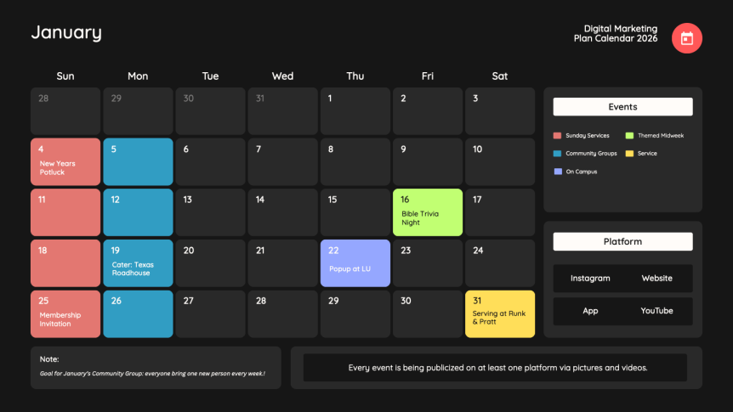
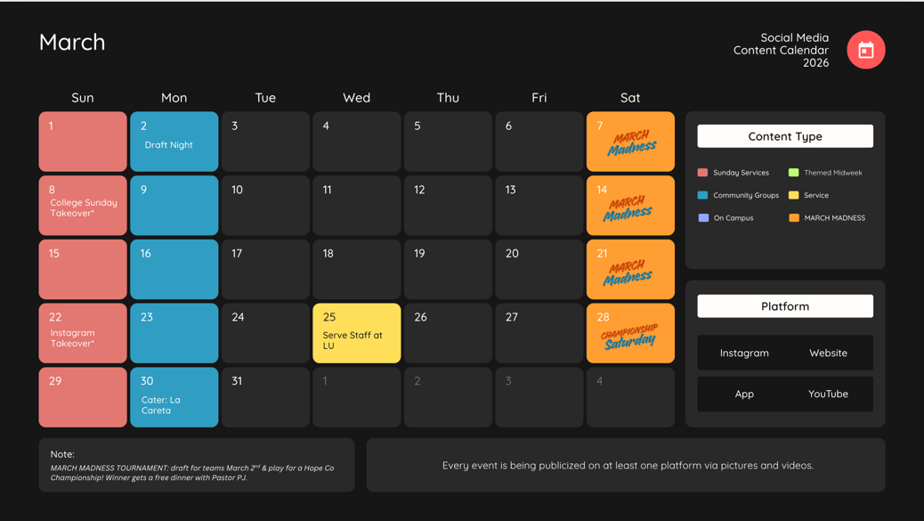
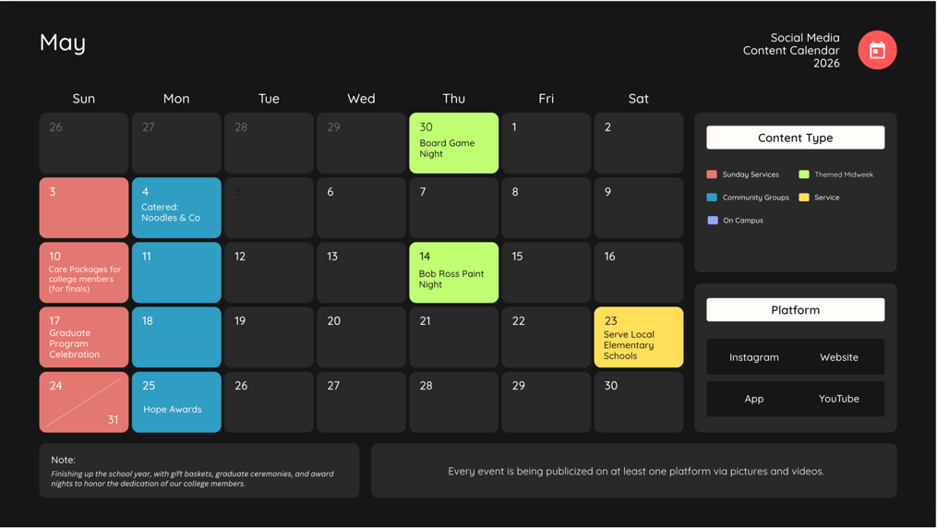

Communication Tactics
As mentioned before, the goal is to increase Instagram following and engagement. Instagram is the media of choice because the account is already established and growing. Secondly, there is a need to update three other platforms: the Hope Co App, website, and YouTube. The app has poor user interaction and features. It is hard to find everything you need. Similarly, to the app, the website has a limited amount of information. It also has terrible SEO. There are other Hope Company churches in America, and Lynchburg’s doesn’t rise to the top. The interface is outdated. Updates necessary are features like ‘getting to know the pastors’, visuals, and videos of people in the church, and embedded links. Finally, the YouTube has an awesome section for live and past sermons. It would be beneficial to see vlogs and videos of church events and worship nights.
Benchmarks
Success in numbers would look like gathering three more students a week from Jan. 1st, 2026, to the end of next year. Or gaining five college student Instagram followers a month. Further, increasing undergrad membership through two more members a month. All of these metrics would be tracked from the numbers currently, in a spreadsheet, to the increase in a calendar year.
On the other hand, success would also look like having zero members come to Hope Co, but the present college body be more on fire and engaged than ever. Numbers and physical changing don’t have to be made to find spiritual success. In Proverbs 16:13 it declares, “Commit your works to the Lord, and your plans will be established”, (NIV, 2020). Attendance skyrocketing isn’t the only mark of a successful campaign. The Hope Company is a church who values its people and their love for the Lord. This marketing plan can build stats, but further its main goal is to promote and cultivate the college student’s involvement and faithfulness to a congregation.

Notes
*using primarily Liberty University students testimonials and examples because it is the largest campus in Lynchburg, and the most consistent college, church-going population. Further the Pastors are connected with the University through sports shepherding and the worship team.

Resources
Changing the Landscape of Giving. (2024). Eden Group.
https://www.theeden.group/blog/changing-the-landscape-of-giving-how-millennials-amp-generation-z-outshine-older-donors-in-giving-to-the-church

Generation Z Fact Sheet. (2024). PRRI. https://prri.org/spotlight/prri-generation-z-fact-
sheet/#:~:text=Generation%20Z%20(%20Gen%20Z%2C%20Generation%20),they%20attend%20religious%20services%20once%20a%20week.

Lynchburg Named ‘Third Most Bible-Minded City’ in U.S. (2024). Liberty University News
Service. https://www.liberty.edu/news/2014/01/31/lynchburg-named-third-most-bible-minded-city-in-u-s/
Mission. (2025). The Hope Company. https://www.hopeco.church
Proverbs 16:13. (2020). New International Version. Bible Gateway.
https://www.biblegateway.com/passage/?search=Matthew%2016%3A18&version=NIV
Young Adults Lead a Resurgence in Church Attendance. (2025). The Barna Group.
https://www.barna.com/research/young-adults-lead-resurgence-in-church-attendance/

